**Como instalar Mosquitto Broker en la Raspberry Pi**

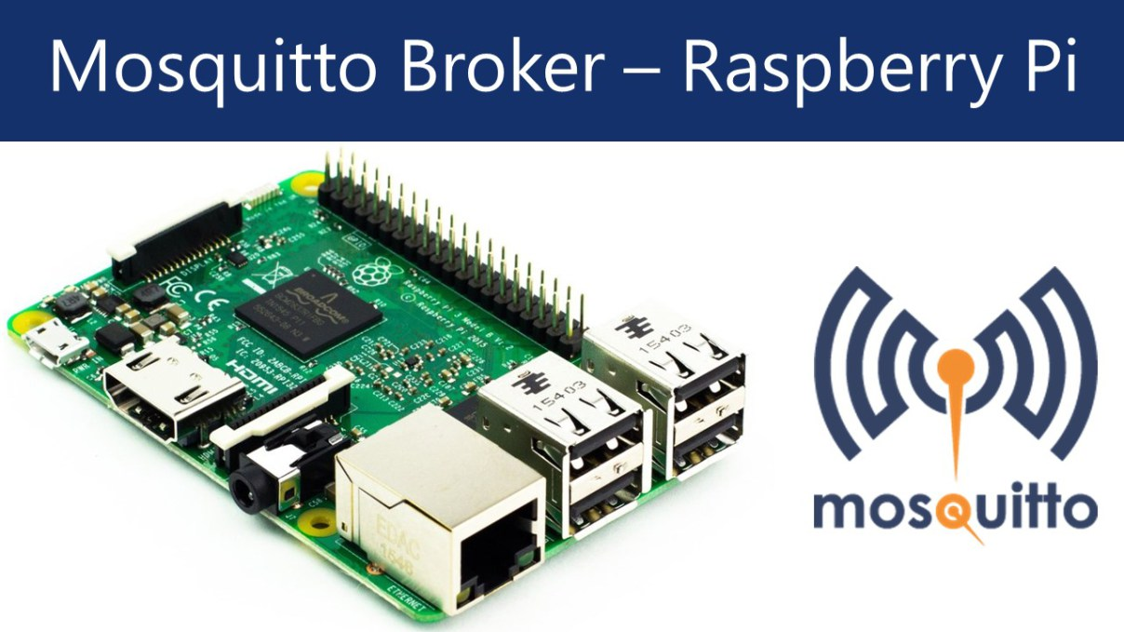

El intermediario es el principal responsable de recisudo bir todos los mensajes, filtrar los mensajes, decidir quién está interesado y luego publicar el mensaje a todos los clientes suscritos. 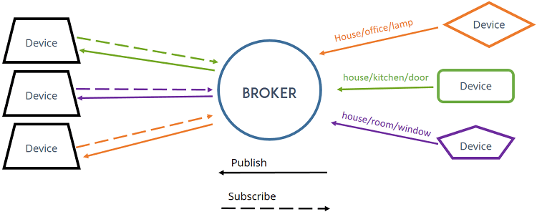

Para instalar Mosquitto Broker:

**pi@raspberrypi:~$ sudo apt-get update**

**pi@raspberrypi:~$ sudo apt-get install -y mosquitto mosquitto-clients**

Para automatizar su arranque:

**pi@raspberrypi:~$ sudo systemctl enable mosquitto.service**

Testing MQTT Broker Installation

After [installing MQTT Broker](https://randomnerdtutorials.com/how-to-install-mosquitto-broker-on-raspberry-pi/), I recommend installing an MQTT Cllient to test the Broker installation and publish sample messages.

The next command shows how to install MQTT Mosquitto Client:

pi@raspberry:~ $ **sudo apt-get install mosquitto-clients**

You’ll have to type **Y** and press **Enter** to confirm the installation.

Run Mosquitto on background as a daemon:

pi@raspberry:~ $ **mosquitto -d**

Subscribing to testTopic Topic

To subscribe to an MQTT topic with Mosquitto Client open a terminal Window #1 and enter the command:

pi@raspberry:~ $ **mosquitto_sub -d -t testTopic**

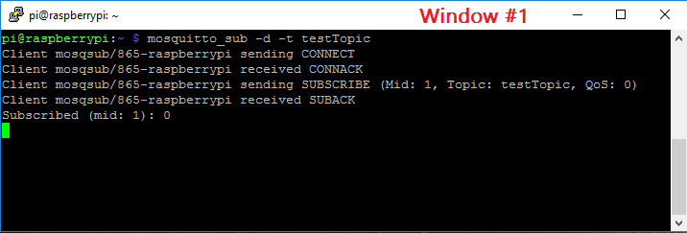

You’re now subscribed to a topic called **testTopic.**

Publishing “Hello World!” Message to testTopic Topic

To publish a sample message to **testTopic**, open a terminal Window #2 and run this command:

pi@raspberry:~ $ **mosquitto_pub -d -t testTopic -m "Hello world!"**

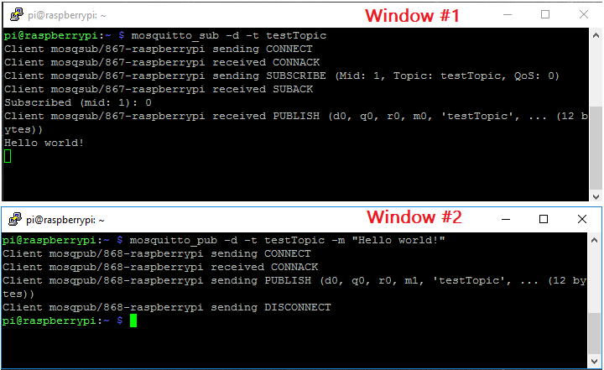

The message “**Hello World!**” is received in Window #1 as illustrated in the figure above.

Publishing a Message to Multiple Clients

Having Window #1 still subscribed to topic testTopic, open a new terminal Window #3 and run this command to subscribe to **testTopic** topic:

pi@raspberry:~ $ **mosquitto_sub -d -t testTopic**

On Window #2 publish the “**Hello World!**” message:

pi@raspberry:~ $ **mosquitto_pub -d -t testTopic -m "Hello world!"**

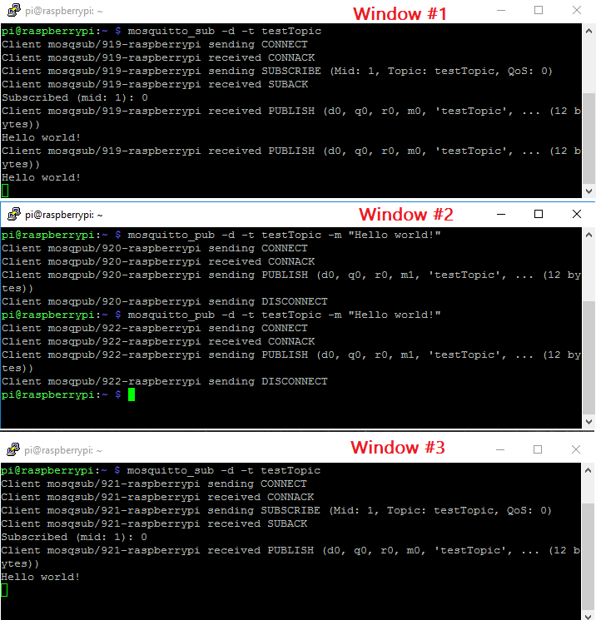

Since two clients are subscribed to **testTopic** topic, they will both receive **“Hello world!”** message.

**MQTT en PYTHON (paho)**

**Paho** es un esfuerzo de la fundación Eclipse por tener librerías para **MQTT** en cualquier lenguaje de programación, incluyendo **Python.**

**INSTALACIÓN**

**$ sudo pip3 install paho-mqtt**

<https://github.com/eclipse/paho.mqtt.python>

**PUBLICACIÓN**



**SUSCRIPCIÓN**

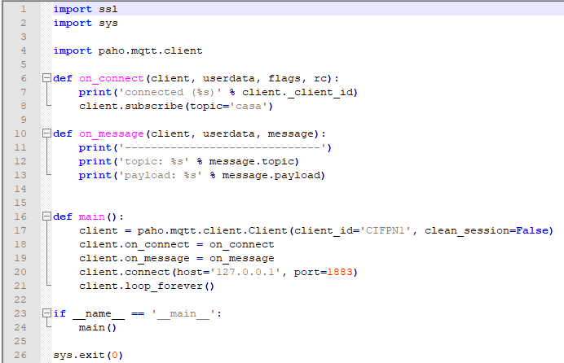

Este link explica, muy bien, en castellano que es MQTT

<https://www.albertcoronado.com/2018/07/07/iot-con-mqtt-mosquitto-python/>